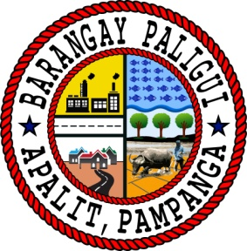Republic of the Philippines

Region III

Province of Pampanga

Municipality of Apalit

**BARANGAY PALIGUI**

*Office of the Sangguniang Kabataan*

|  |  |  |  |  |  |  |
| --- | --- | --- | --- | --- | --- | --- |
| **Reimbursement for October 2024** | | | | | | |
| SK Barangay Paligui | | | | | | |
| Paligui, Apalit, Pampanga | | | | | | |
|  |  |  |  |  |  |  |
| **ACTIVITY** | **EXPENSE** | A**MOUNT** | **REMARKS** | | | |
| Educational Assistance | Financial Assistance | 115,000.00 | Senior High and College Financial Educational Assistance | | | |
| Linggo ng Kabataan | Training Equipment | 5,300.00 | MJDT Cup Inter Barangay Volleyball League 2024 | | | |
| Player Allowance | Allowances | 14,000.00 | MJDT Cup Inter Barangay Volleyball League 2024 | | | |
| Interbarkada Basketball League | Expenses | 14,700.00 | Inter-barkada basketball league awarding | | | |
|  |  |  |  | | | |
|  |  |  |  | | | |
|  |  |  |  | | | |
|  |  |  |  | | | |
|  |  |  |  | | | |
| **TOTAL** |  | 149,000.00 |  | | | |



Prepared By: Approved By:

Ms. Angel Mae B. Bautista Hon. Arjay L. Saclao

SK Treasurer SK Chairperson